***THE JUMEIRAH***

Jumeirah Beach is one of the most iconic and popular beaches in Dubai, United Arab Emirates. Here’s everything you need to know about Jumeirah Beach:

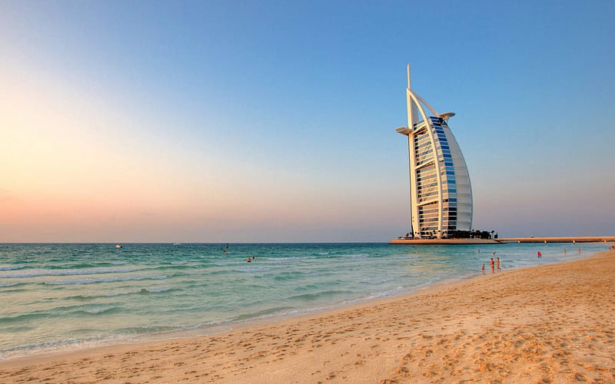**Location**: Jumeirah Beach stretches along the coastline of the Jumeirah district in Dubai. It is easily accessible and located near major landmarks such as the Burj Al Arab hotel and the Palm Jumeirah.

The beach boasts pristine white sands and clear turquoise waters, set against the backdrop of Dubai's impressive skyline. It offers stunning views of the Arabian Gulf and is a favorite spot for both locals and tourists alike.

Jumeirah Beach is well-equipped with amenities such as sun loungers, umbrellas, showers, and changing facilities. There are also beachfront cafes and restaurants where visitors can enjoy refreshments and meals with a view.